**HEALTH CARE MANAGEMENT**

**A PROJECT REPORT**

**Submitted by:**

**KARAN AGRAWAL(171620101050)**

**VEDANT SONI(171620101040)**

**MAHARSHI DAVE(16012101045)**

**VRAJ NIRAV DESAI(16012101005)**

***in a partial fulfillment of for Application Development Project (SEN-IV)***

***of***

**BACHALOR OF TECHNOLOGY**

**IN**

**COMPUTER SCIENCE AND ENGINEERING (CBA/BDA/MA)**

at



**2018-19**

**DECLARATION**

I hereby declare that the project entitled “HEALTH CARE MANAGEMENT SYSTEM” submitted for the B. Tech. CSE (CBA/BDA/MA) Application Development Project is my original work.

**Vraj Desai**

**Signature of the Student**

**Place: Ganpat University ICT,Ahmedabad.**

**Date: 30th April,2019**

**DECLARATION**

I hereby declare that the project entitled “HEALTH CARE MANAGEMENT SYSTEM” submitted for the B. Tech. CSE (CBA/BDA/MA) Application Development Project is my original work.

**Agrawal Karankumar**

**Signature of the Student**

**Place: Ganpat University ICT,Ahmedabad.**

**Date: 30th April,2019**

**DECLARATION**

I hereby declare that the project entitled “HEALTH CARE MANAGEMENT SYSTEM” submitted for the B. Tech. CSE (CBA/BDA/MA) Application Development Project is my original work.

**Vedant Soni**

**Signature of the Student**

**Place: Ganpat University ICT,Ahmedabad.**

**Date: 30th April,2019**

**DECLARATION**

I hereby declare that the project entitled “HEALTH CARE MANAGEMENT SYSTEM” submitted for the B. Tech. CSE (CBA/BDA/MA) Application Development Project is my original work.

**Dave Maharshi**

**Signature of the Student**

**Place: Ganpat University ICT,Ahmedabad.**

**Date: 30th April,2019**

**CERTIFICATE**

This is to certify that the project titled “HEALTH CARE MANAGEMENT SYSTEM” submitted by ***VRAJ NIRAV DESAI(16012101005)*** of B Tech (CSE)-SEM IV of CBA/BDA/MA from Institute of Computer Technology, Ganpat University during the academic year 2018-19, in partial fulfillment of the requirements for the Application Development project work.

**Signature of the Guide**

**Place: Ganpat University ICT,Ahmedabad.**

**Date: 30th April,2019**

**CERTIFICATE**

This is to certify that the project titled “HEALTH CARE MANAGEMENT SYSTEM” submitted by ***AGRAWAL KARANKUMAR (17162101050)*** of B Tech (CSE)-SEM IV of CBA/BDA/MA from Institute of Computer Technology, Ganpat University during the academic year 2018-19, in partial fulfillment of the requirements for the Application Development project work.

**Signature of the Guide**

**Place: Ganpat University ICT,Ahmedabad.**

**Date: 30th April,2019**

**CERTIFICATE**

This is to certify that the project titled “HEALTH CARE MANAGEMENT SYSTEM” submitted by ***VEDANT SONI(17162101040)*** of B Tech (CSE)-SEM IV of CBA/BDA/MA from Institute of Computer Technology, Ganpat University during the academic year 2018-19, in partial fulfillment of the requirements for the Application Development project work.

**Signature of the Guide**

**Place: Ganpat University ICT,Ahmedabad.**

**Date: 30th April,2019**

**CERTIFICATE**

This is to certify that the project titled “HEALTH CARE MANAGEMENT SYSTEM” submitted by ***DAVE MAHARSHI(16012101045)*** of B Tech (CSE)-SEM IV of CBA/BDA/MA from Institute of Computer Technology, Ganpat University during the academic year 2018-19, in partial fulfillment of the requirements for the Application Development project work.

**Signature of the Guide**

**Place: Ganpat University ICT,Ahmedabad.**

**Date: 30th April,2019**

**Table of Contents**

**TitlePage……………………………………………………………………………………....(1)**

**Declaration of the Student……………………………………………………………………(2)**

**Certificate of the Guide……………………………………………………………………….(3)**

**Abstract………………………………………………………………………………………..(6)**

**Acknowledgement……………………………………………………………………………..(5)**

**Introductions…………………………………………………………………………………(8)**

**1.1 Problem of Defination…………………………………………………………………..(8)**

**1.2 Project Overview…………………………………………………………………………(8)**

**1.3 Hardware Specification………………………………………………………………….(8)**

**1.4 Software Specification……………………………………………………………………(8)**

**Requirements Analysis……………………………………………………………………..(9-10)**

**System Analysis and Design………………………………………………………………….(10)**

**3.1 Requirement Specification…………………………………………………………(10-11)**

**3.2 Flow Charts/ERDs/DFDs………………………………………………………………(12)**

**3.3 Design and Test Steps…………………………………………………………………..(13)**

**3.4 Algorithms and Pseudo Code……………………………………………………………**

**3.5 Testing Process…………………………………………………………………………..(14)**

**Result/Output……………………………………………………………………………(14-15)**

**Conclusion…………………………………………………………………………………….(15)**

**Refrences………………………………………………………………………………………(16)**

**Acknowledgement**

This research was supported by Institute of Computer Technology. We thank our professors and guides who provided insight and guidance that greatly assisted the project.

We thank ***Prof. Umang Shukla*** and ***Prof. Angshuman Chatterjee*** for assistance with definition selection and selection of technology to use in project.

We would also like to show our gratitude to the faculties for sharing their pearls of wisdom with us during the course of this project work. We are also grateful to the faculties for encouraging us to learn a new technology and implement its knowledge in our project.

**Abstract**

* Health care management website is basically website for users who can easily book their appointment with the respective doctors.
* Website does not have any types of limitations in field of doctors.
* We will try to connect every field of doctors to these website so that patients have not to face any types of problems in booking appointments.

**1.INTRODUCTION**

**1.1) PROBLEM OF DEFINATION:**

* Healthcare records of people, in a developing nation like India, up to an extend is not kept properly.
* This is due to the fact that current Government Hospitals or Clinics do not have or

support an infrastructure/Database to store a person’s past medical history.

* In developed nations, healthcare records of their citizens including past medical

treatments, insurance details, prescriptions etc. are stored in Government

Databases.

* These records help physicians in knowing the health condition of patient from past

treatments rather than wasting time in diagnosing their health condition.

* A patient may have allergic reactions to some chemicals in a specific prescription

that could be life threatening if not known beforehand to the physician.

**1.2) PROJECT OVERVIEW/SPECIFICATIONS**

* In this project we have used PHP language for developing the website.
* This website contains 2 moduls. 1)User Side & 2)Admin Side.
* In user side module you can create your account and sign in into the website.
* After that you can check you can check website and select appoinments.
* In admin side module you can see the user’s database like name,e-mail address,address,etc.

**1.3) HARDWARE SPECIFICATIONS**

* For a better registration form we have observed some forms of hospitals.

**1.4) SOFTWARE SPECIFICATIONS**

* We have used sublime text software for built our website and use wamp server for its preview.

**2.REQUIREMENT ANALYSIS**

* To know the requirement of this website we have survey some people by google forms which are as below.

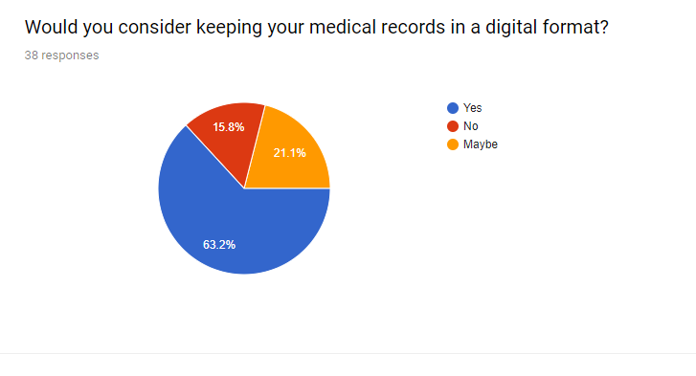

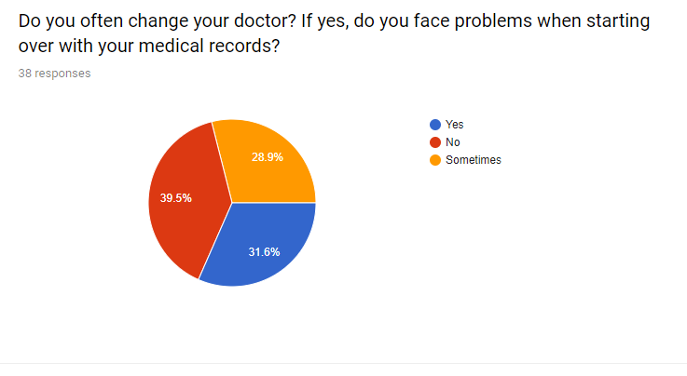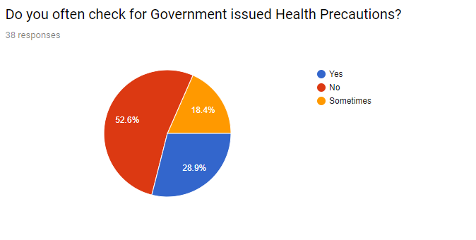

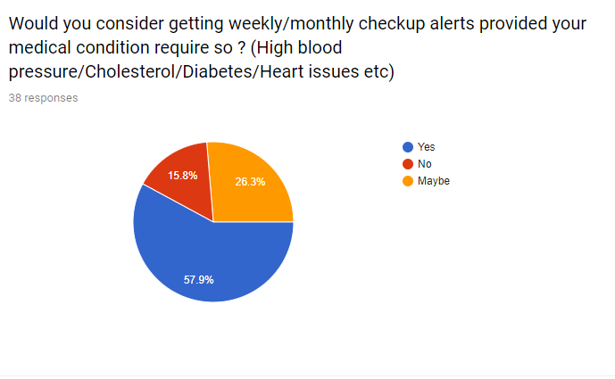 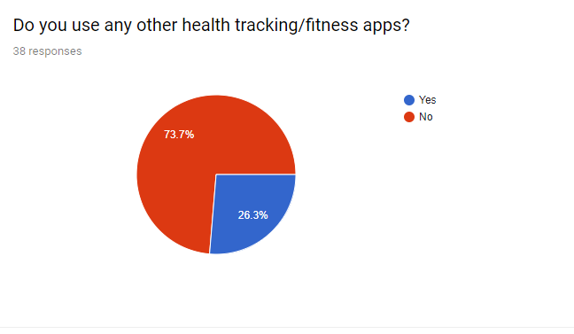

**3.SYSTEM ANALYSIS AND DESIGN**

**3.1)Requirement Specifications**

* Hardware Requirements.
* Dual Core Processor.
* 4 GB RAM.
* 20 GB Disk Memory.
* Sofftware Requirements.
* Windows XP,7,8,10 or Linux
* Xampp/Wamp Server
* PhpMyAdmin
* Google Chrome/Mozilla FireFox/Other Browser
* SQL 2008 DataBase System or Later Version
* Technology Requirement.
* PHP
* CSS
* **XAMPP/WAMP :**

It is an application which provides the facility of local server on a computer system which provides server environment for websites to run on local systems. This local servers are used as a websitecan be tested well on a server and a developer cannot put a website that is underdevelopment on an actual

server.

Xampp/Wamp server in this project helps to run the PHP coded pages on local server along with other codes.

* **SQL 2008 DATABASE SYSTEM :**

This is a SQL (Structured Query Language) system with 2008 version and is

used for database connections.

* **PhpMyAdmin:**

PhpMyAdmin is an application (browser application) and is used for database connection. We have used this application for database connection in our project. This is an local server based application which can be accessed by installing Xampp/Wamp server application on your system.

**3.2) FLOWCHARTS/ERDs/DFDs**

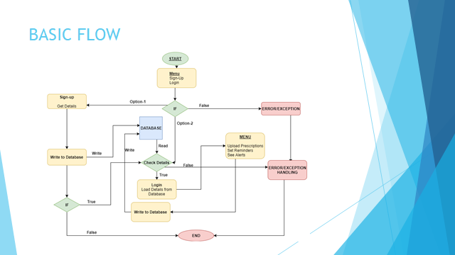

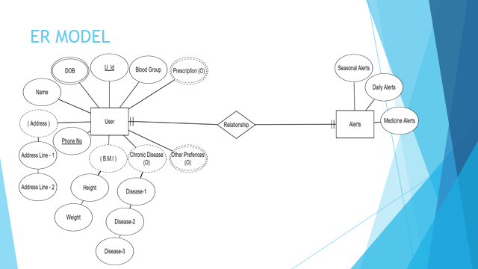

**3.3) Design And Test Steps**

Step1: Open (Initialize) the website by opening the home page file i.e index.php file.

Step2: Now for homepage user can redirect to the different pages, which are – Registration Page, Sign-In Page and Contact Us Page.

Step3: After the user has registered himself as any of the available users by filling all the required details, the user is redirected to the sign-up (login page). If the user already has an account, he can directly login.

Step4: After the user has successfully logged-in, he is redirected to the user dashboard where the user can view all the job postings according to his choice and skills or view job applications based on type of user. He can go through his registration details, edit details, change password, etc from side panel.

Step5: The user can post a job or accept a job from user dashboard based on type of users. The users can view employer name, job description, deadline for submission of task, and other details by clicking on the job title. Once a user has applied for the job, he/she has to wait until the employer confirms his/her application. As soon

as the employer confirms the application the user can start working on the task.

Step6: Once the confirmation has been received/provided the user can either logout or explore more based on their will.

Step7: Once the task has been completed the user has to upload their work on the website and wait for the

employer to transfer the promised amount in your account. After completion of job the user can explore more.

**3.4) Algorithm and Pseudo Code**

Every functionality of the website has an algorithm.

For database connection: 1.) Connection is established when the application is started.

2.) When data-fields are filled the data is inserted to database based on the type of data to the corresponding database table.

3.) When data is to displayed in the text-fields the data is requested from the database from the database table based on type of data for specific conditions by firing query in methods created.

Pseudo Code for Database connection:

<?php

$con=MySQLi_connect("localhost","root","","patients") or die(mysql_error());

$db=MySQLi_select_db($con,'patients') or die(mysql_error());

?>

**3.5)Testing Process**

We haven’t provided the application to various users for testing but the website has been tested in lab sessions by the respective faculties and by the developers. The website has not been hosted on web servers.

**4) RESULTS/OUTPUTS**

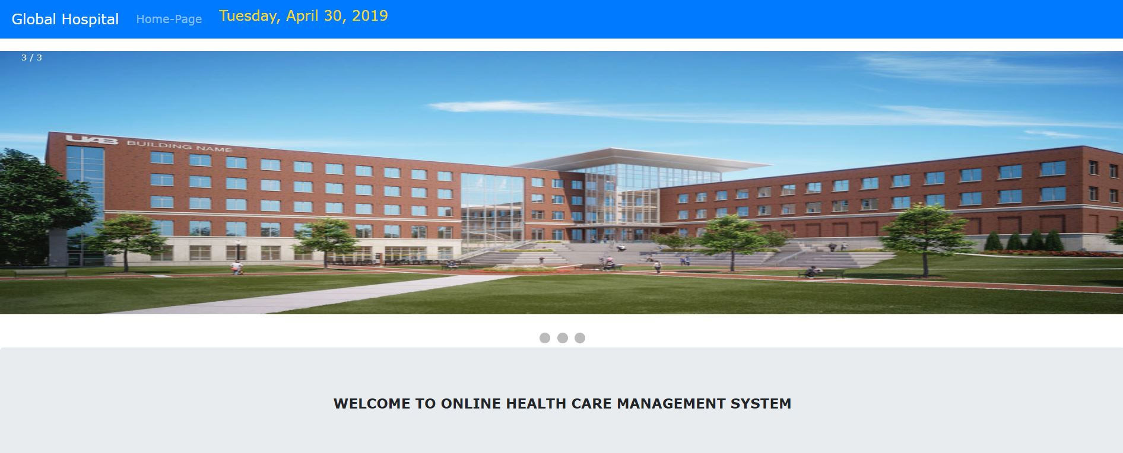

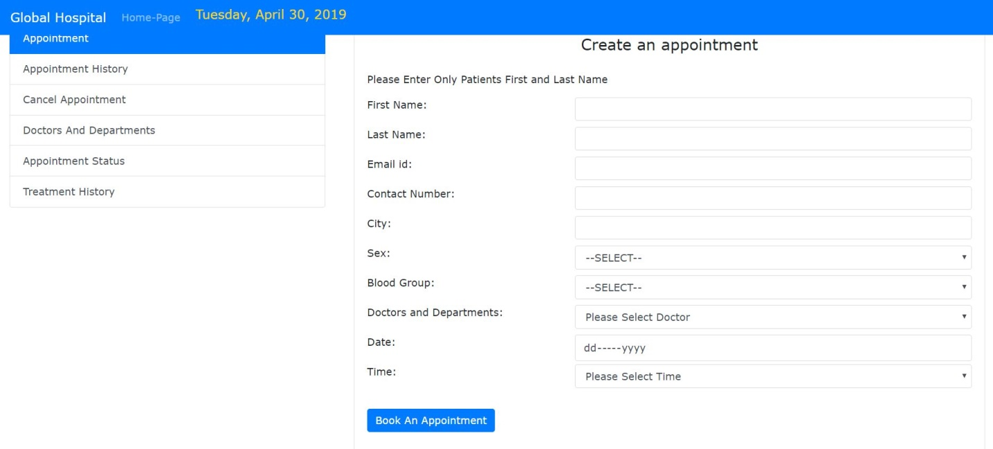

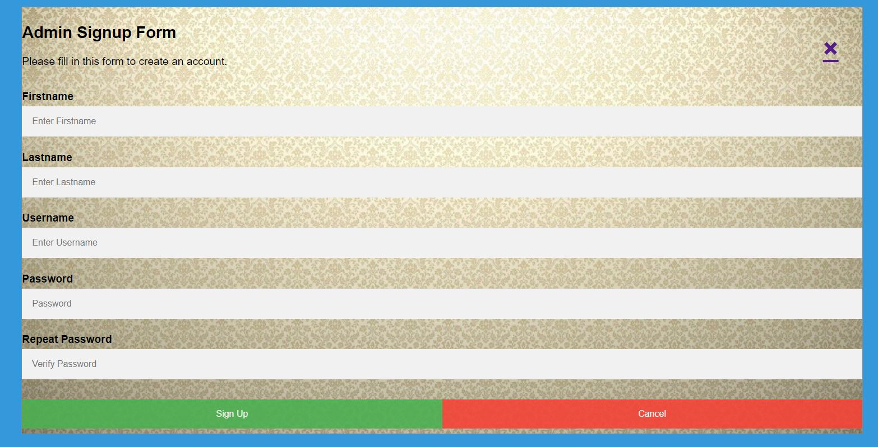

**5.CONCLUSION**

There are many and various job providing websites on the internet and some of them might be having better concepts than ours, but Rozgaar’s aim is not to compete with the others but is to provide people the facilities and environment in which they would love to work. We want the elders to be active and take least work load and physical pressure, we want young kids to explore various opportunities, we want youngsters to take a step

forward to their brighter future, we want housewives to feel that their knowledge and skills can be very useful to them and to others too, we want people to gain knowledge, we want people to become productive and have progress and above all that we want people to help others and themselves for a better life and this is where you

can get a start.

**6.REFRENCES**

* StackOver Flow
* GeeksfoGeeks
* Wikipedia
* Github
* Youtube